Phenix Payton
NET 2300
Ingress file to sanitizer_in topic
4/1/26
Insert a CSV file into job_request
Done with ingress-db.sh:
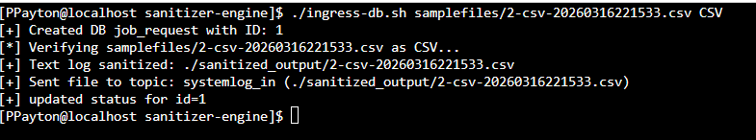
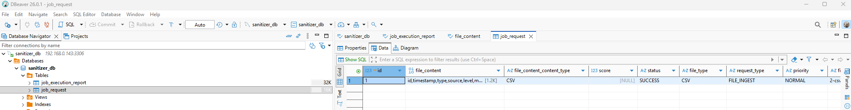
Read from job_request, construct JSON file, and send to sanitizer_in Kafka topic
